This week, we’ll do some background research for our final project, which is focused on the learning outcome: Students will be able to formulate climate adaptation and mitigation strategies for a region of their choice. We'll consider the climate and extreme weather risks where you live and where you might want to live in the future. Read this New York Times article about Every Place Has Its Own Climate Risk. What Is It Where You Live? At the top of the article, you'll find an interactive map that lets you explore the climate and extreme weather risks for your county. Look at the general climate threats for the whole country, then type in your current county to see the greatest climate threat where you live. Also explore where climate risks seem the least and consider which climate risks you're more comfortable living with than others.
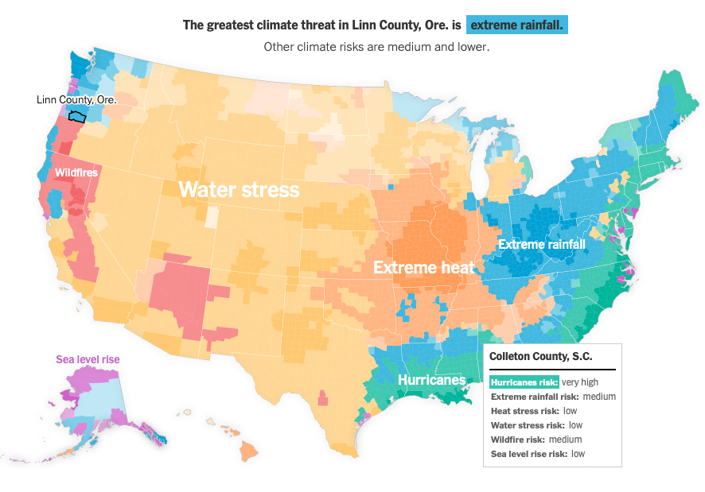
Consider,
- What is/are the greatest climate threat(s) where you live?
- What issues do these climate threats pose for your local communities and ecosystems?
- Where would you move to if climate threats were your primary concern?
- What are the climate threats there and why are you willing to live there?
Let's discuss using an interactive map on this US Map Miroboard. The first frame shows the template discussion prompt and an example, which is my answer. The second frame is where you'll duplicate the template and fill in your own information. Your post is due on Wednesday of Week 2.
Throughout the week, look at what your peers are posting. Where are people choosing? Who has the best argument for why they would live where they would? Please vote on the top two locations by commenting on the sticky note, by Sunday of Week 2. Comments can include relating to similar threats or concerns, reflecting on additional climate threats that were not included in the article, and explaining why you agree with their argument, etc. Comments should be 2-3 sentences. The two students with the most votes get +5 bonus points, so try to come up with a good argument for your location!
Rubric (25 pts total)
- Fill in your name, current location, and greatest climate threat (3 pts)
- Explain 1-2 issues that climate threats pose your current region, in 2-3 sentences (4 pts)
- Identify somewhere else you’ve thought about living (2 pts)
- Explain 1-2 climate threats there and how those threats influence your decisions, in 2-3 sentences (4 pts)
- Put sticky notes with your name near your 1) current location and 2) future location (4 pts)
- Post should be neat, with well-connected ties, and not overlap with other students as much as possible (2 pts)
- Comment on two student’s post, in 2-3 sentences (6 pts, 3 pts for each comment)

